COURSE CODE/TITLE: | CPE010 |  | SECTION: | CPE21S3
DATE PERFORMED: | 7/16/26 |  | DATE SUBMITTED: | 7/20/26
NAME: | Ralf Nicolo B. Abello |  | INSTRUCTOR: | Engr. Jimlord Quejado

ACTIVITY NO. 2.1 | Arrays, Pointers and Dynamic Memory Allocation
1. PROCEDURE OUTPUT
Screenshot | 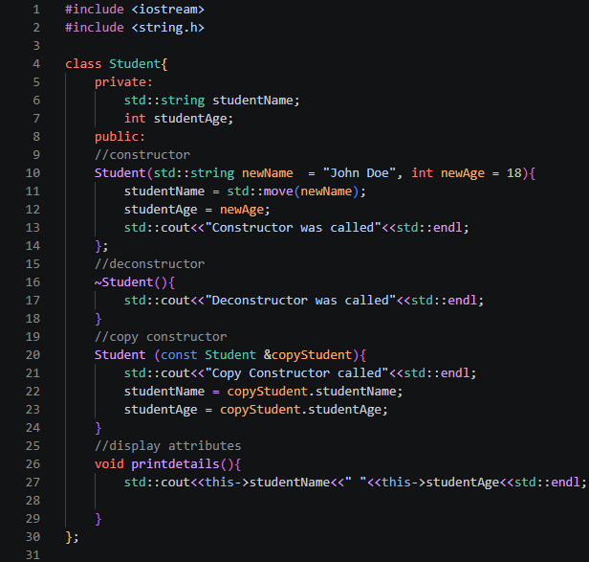  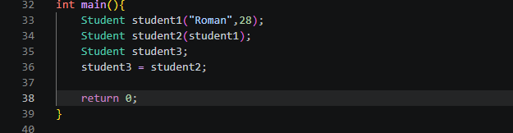  Output:  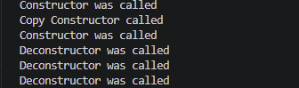
Observation | This program starts with the class that is named Student with two private members, studentName and studentAge, plus four member functions: a constructor, a destructor, a copy constructor, and printDetails().For the constructor it takes a name and age (defaulting to "John Doe" and 18 if none are given), then uses std::move to efficiently transfer newName's data into studentName instead of copying it, and simply copies newAge into studentAge. The copy constructor runs whenever a new Student object is initialized from an existing one (not assigned, initialized) as an exact duplicate of an existing object.Lastly the destructor releases the memory that we initialized after the program ends.  For the main() we initialized Student student1("Roman", 28); which calls the constructor, next is Student student2(student1); which then copies student1 then put it in student2. For the student3 it calls the default constructor and after it was then assigned that it will copy student2 into student 3. When main() returns student3, student2, and student1 go out of scope in reverse order of declaration which then triggers the destructor three times.
Table 2-1. Initial Driver Program

Screenshot | 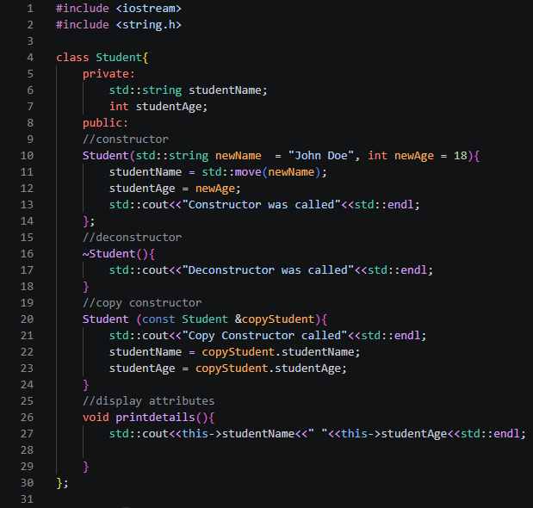  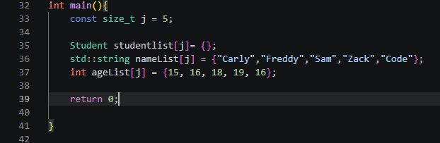  Output:  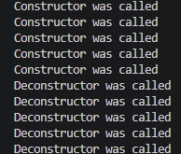
Observation | In main(), I declare a stack array studentList of 5 default-constructed Student objects, which immediately triggers 5 calls to the default constructor (printing "Constructor was called" 5 times) since no arguments are supplied at declaration. I then use two parallel arrays, nameList and ageList, to hold the real student information, but nothing links them to studentList until I loop through and fill it. In that loop, I use new Student(nameList[i], ageList[i]) to heap-allocate a temporary object, then assign it into the already-existing studentList[i] via studentList[i] = *ptr. Because studentList[i] already exists at that point, this tells the compiler-generated copy assignment operator rather than my custom copy constructor, so my "Copy Constructor called" message never prints for these assignments. A second loop then correctly calls printDetails() on each element of studentList, confirming the real names and ages were assigned successfully, and when main() returns, the 5 stack-allocated Student objects unwind and their destructors prints in order.
Table 2-2. Modified Driver Program with Student List

Loop A | 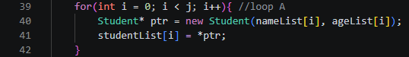
Observation | This loop fills in the real student data. On each pass, I use new Student(nameList[i], ageList[i]) to heap-allocate a fresh Student object with the correct name and age, calling the constructor (which prints "Constructor was called"). Then *studentList[i] = ptr dereferences that pointer and assigns the values into the existing studentList[i] slot. Because studentList[i] was already constructed back in main's initialization, this is assignment, not copy construction, so it silently uses the compiler's default operator= to copy studentName and studentAge member by member. ptr itself is never deleted, so the heap object it points to leaks memory once ptr goes out of scope or gets reassigned next iteration.
Loop B | 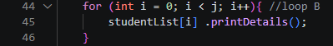
Observation | This loop just reads and displays the final state of the array. For each element in studentList, I call printDetails(), which prints studentName and studentAge using this->. No construction, destruction, or assignment happens here, it's purely output, and it confirms that loop A successfully copied the correct name/age values into every slot of studentList.
Output | 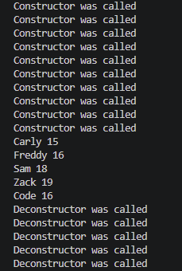
Observation | Loop A correctly populates studentList with the right names and ages by using new Student(nameList[i], ageList[i]) to build each student, then assigning it into the array slot with *studentList[i] = ptr. Because studentList[i] already exists at that point, this assignment calls the compiler-generated copy assignment operator, not the custom copy constructor I wrote, so “Copy Constructor called” never prints. The ptr pointer is never deleted, so the heap-allocated Student object it points to is never destructed, meaning its destructor never runs either. So while the final data in studentList ends up correct, the copy constructor goes unused and the heap object created by new is never cleaned up.
Table 2-3. Final Driver Program
2. ANSWERS TO SUPPLEMENTAL ACTIVITY
Code:
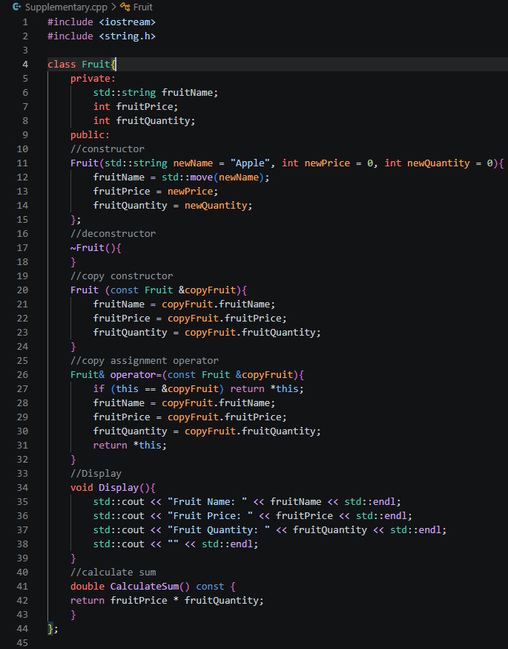
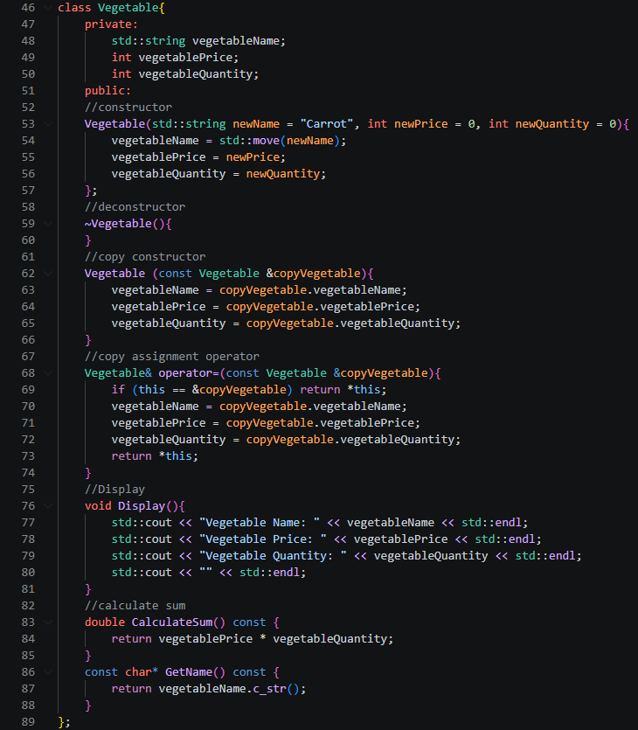
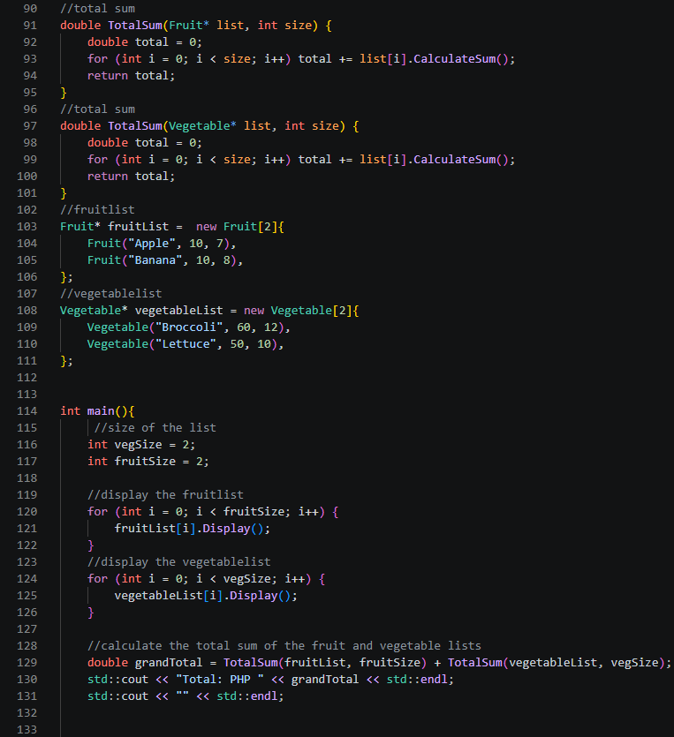
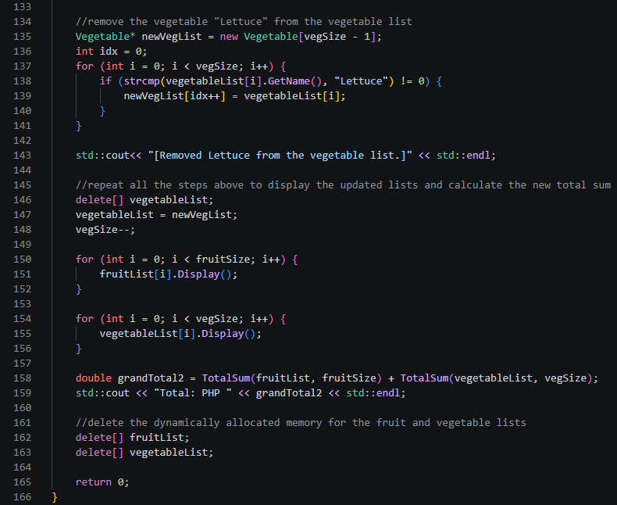

Output:
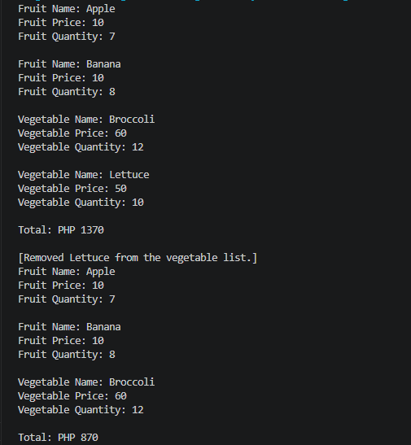

Code Analysis:
In this supplementary activity, I declared two classes, Fruit and Vegetable, that follow nearly identical patterns to represent inventory items with a name, price, and quantity. I gave each class a constructor with default arguments (like "Apple" or "Carrot") so I can create objects without always specifying every value, and I used std::move(newName) to efficiently transfer the string argument into my member variable instead of copying it. I also wrote a copy constructor for each class that performs a deep member-wise copy, which matters because when I later do newVegList[idx++] = vegetableList[i], I'm relying on correct copy behavior (technically here it's the compiler-generated copy assignment operator doing the work, since I never overloaded operator= myself, but it behaves correctly because my members are simple value types like std::string and int). Each class also has a Display() method to print its fields and a CalculateSum() method that multiplies price by quantity, both marked const so I can safely call them on read-only objects. To handle sums across whole arrays, I wrote two overloaded TotalSum() functions, one for Fruit* and one for Vegetable*, both looping through a raw array and accumulating the total.

For my data, I allocated fruitList and vegetableList as dynamic arrays on the heap using new Fruit[2]{...} and new Vegetable[2]{...}, initialized with two items each. In main(), I display both lists, calculate a grandTotal, then simulate removing "Lettuce" from the vegetable list. Since arrays can't shrink in place, I handle this by allocating a newVegList one element smaller, looping through the old list, and copying over every vegetable whose name doesn't match "Lettuce" (I compare with strcmp() since GetName() returns a const char* via c_str()). After copying, I delete[] vegetableList to free the old memory, reassign the pointer to newVegList, and decrement vegSize to keep my size tracking accurate. I then redisplay both lists and recompute the total to confirm the removal worked. One thing I notice looking back at my own code: I declared fruitList and vegetableList as global pointers initialized with dynamic allocation before main() even runs, which works but isn't ideal practice since it makes memory management less contained. At the very end, I clean up with delete[] fruitList and delete[] vegetableList to avoid memory leaks.

Conclusion:
Working through this activity taught me how the "big three" (constructor, copy constructor, destructor) control an object's life from start to finish. I especially learned the difference between initializing an object, which calls my copy constructor, and assigning to one that already exists, which quietly uses the compiler's own operator= instead, something I only understood after tracing why my "Copy Constructor called" message never printed in Table 2-3's loops. The initial and modified driver programs were easy to follow since I just watched how stack-allocated Student objects called their constructor and destructor in order. The student list exercise made me think harder about pointer lifetimes, since I noticed my ptr variable was never deleted after I dereferenced it into studentList[i], meaning every Student I created with new was quietly leaking memory. The supplementary activity with Fruit and Vegetable was genuinely challenging for me, since shrinking an array isn't natively supported in C++. I had to manually create a smaller array, copy over the vegetables that didn't match "Lettuce" using strcmp(), and properly delete[] the old array before pointing to the new one, a step I hadn't needed before and had to work through carefully. Overall, I understood the core ideas of memory management and object lifecycles well, but I still have room to grow in writing cleaner, safer code and being more mindful of memory management overall, since this activity showed me how easily a leak can happen even when the program still runs and prints the right output.
3. ARTIFICIAL INTELLIGENCE (AI) USE DISCLOSURE STATEMENT
I hereby declare that artificial intelligence (AI) tools were used, if applicable, in the preparation of this academic work. The following indicates the nature and extent of AI assistance:

Tools Used: | ChatGPT
Examples: ChatGPT, Microsoft Copilot, Grammarly, QuillBot, etc.

Purpose of Use: | Grammar, Explanation of concept & code assistance
Examples: grammar correction, idea generation, formatting, summarization, code assistance, explanation of concepts, etc.

Extent of Use: | I used it to explain how the code works to understand it more on a deeper level and to debug the code to find why my code is not working
Explain how AI was used and confirm that it did not replace original thinking, analysis, authorship, or completion of the required work.

By submitting this activity, I affirm that my use of AI complies with T.I.P.’s AI usage policy and does not exceed the permitted limits for similarity, automated content generation, or academic assistance.

I understand that any false, incomplete, or misleading disclosure may be subject to investigation in accordance with due process and may result in sanctions for violation of existing T.I.P. policies.

Lab activities, templates, and related instructional materials shall not be reuploaded, reproduced, distributed, or shared with external organizations or third parties without the prior express written permission of the Technological Institute of the Philippines.

